Skill 08 - Lab - Coffee House and Fallout Local Routing (June 04)
CCNA Packet Tracer Network Design, Configuration, and Path Verification Guide
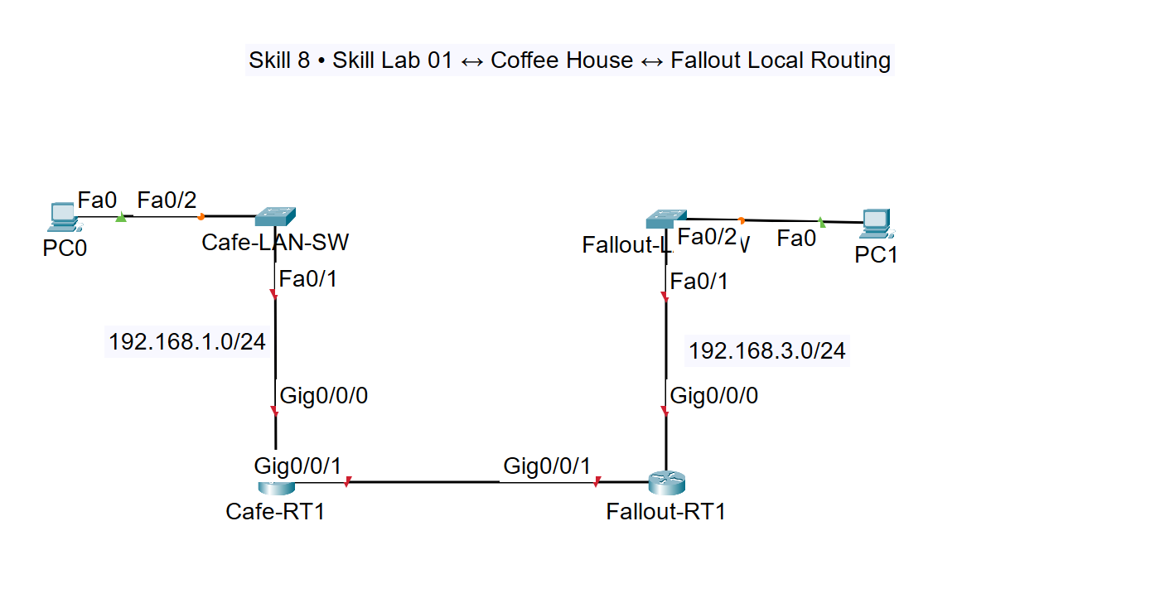
Figure 1. Coffee House and Fallout local-routing topology. PC0 uses 192.168.1.51/24 on the 192.168.1.0/24 LAN.
Important addressing note: This lab uses PC0 address 192.168.1.51/24. The Coffee House LAN is 192.168.1.0/24, and the default gateway is 192.168.1.1.

1. Learning objectives
- Place and cable two PCs, two Layer 2 switches, and two routers in Cisco Packet Tracer.
- Configure two LANs and a /30 point-to-point router link.
- Add static routes so PC0 can reach PC1 across both routers.
- Verify Layer 1, Layer 2, and Layer 3 operation with show, ping, ARP, MAC-table, and traceroute commands.
- Trace the packet path from PC0 (192.168.1.51) to PC1 (192.168.3.101).

2. Required devices
Quantity | Packet Tracer device | Suggested model | Purpose
2 | Router | ISR 4321 | Routes between the two LANs
2 | Switch | 2960-24TT | Provides Layer 2 access connectivity
2 | PC | PC-PT | PC0 and PC1 endpoints
5 | Copper straight-through/automatic | Connections tool | PC-to-switch, switch-to-router, and router-to-router links

3. Network design and addressing plan
Device | Interface | IP address | Mask | Default gateway / next hop | Role
PC0 | Fa0 | 192.168.1.51 | 255.255.255.0 | 192.168.1.1 | Coffee House host
Cafe-LAN-SW | VLAN 1 | 192.168.1.2 | 255.255.255.0 | 192.168.1.1 | Optional switch management
Cafe-RT1 | G0/0/0 | 192.168.1.1 | 255.255.255.0 | — | Coffee House gateway
Cafe-RT1 | G0/0/1 | 10.0.0.1 | 255.255.255.252 | 10.0.0.2 | Router transit link
Fallout-RT1 | G0/0/1 | 10.0.0.2 | 255.255.255.252 | 10.0.0.1 | Router transit link
Fallout-RT1 | G0/0/0 | 192.168.3.1 | 255.255.255.0 | — | Fallout LAN gateway
Fallout-LAN-SW | VLAN 1 | 192.168.3.2 | 255.255.255.0 | 192.168.3.1 | Optional switch management
PC1 | Fa0 | 192.168.3.101 | 255.255.255.0 | 192.168.3.1 | Fallout host

4. Place and cable the devices
- Place the devices: Drag two ISR 4321 routers, two 2960 switches, and two PC-PT computers into the Logical workspace. Rename them PC0, Cafe-LAN-SW, Cafe-RT1, Fallout-RT1, Fallout-LAN-SW, and PC1.
- Cable the Coffee House LAN: PC0 Fa0 to Cafe-LAN-SW Fa0/2; Cafe-LAN-SW Fa0/1 to Cafe-RT1 G0/0/0.
- Cable the transit link: Cafe-RT1 G0/0/1 to Fallout-RT1 G0/0/1.
- Cable the Fallout LAN: Fallout-RT1 G0/0/0 to Fallout-LAN-SW Fa0/1; Fallout-LAN-SW Fa0/2 to PC1 Fa0.
- Wait for link lights: Allow several seconds for interfaces to transition. Router interfaces remain down until no shutdown is configured.

5. Configure the PCs
Packet Tracer PC-PT endpoints are normally configured through the graphical interface rather than Cisco IOS CLI.

PC0 configuration
- Open PC0 > Desktop > IP Configuration.
- IP address: 192.168.1.51
- Subnet mask: 255.255.255.0
- Default gateway: 192.168.1.1

PC1 configuration
- Open PC1 > Desktop > IP Configuration.
- IP address: 192.168.3.101
- Subnet mask: 255.255.255.0
- Default gateway: 192.168.3.1

Verify each PC from Desktop > Command Prompt
ipconfig

6. Configure Cafe-LAN-SW
enable
configure terminal
hostname Cafe-LAN-SW
no ip domain-lookup
interface fastethernet0/2
description PC0 - 192.168.1.51
switchport mode access
spanning-tree portfast
no shutdown
exit
interface fastethernet0/1
description Uplink to Cafe-RT1 G0/0/0
switchport mode access
no shutdown
exit
interface vlan 1
description Switch management
ip address 192.168.1.2 255.255.255.0
no shutdown
exit
ip default-gateway 192.168.1.1
end
copy running-config startup-config

7. Configure Fallout-LAN-SW
enable
configure terminal
hostname Fallout-LAN-SW
no ip domain-lookup
interface fastethernet0/1
description Uplink to Fallout-RT1 G0/0/0
switchport mode access
no shutdown
exit
interface fastethernet0/2
description PC1 - 192.168.3.101
switchport mode access
spanning-tree portfast
no shutdown
exit
interface vlan 1
description Switch management
ip address 192.168.3.2 255.255.255.0
no shutdown
exit
ip default-gateway 192.168.3.1
end
copy running-config startup-config

8. Configure Cafe-RT1
enable
configure terminal
hostname Cafe-RT1
no ip domain-lookushow cppcop
interface gigabitethernet0/0/0
description Coffee House LAN to Cafe-LAN-SW
ip address 192.168.1.1 255.255.255.0
no shutdown
exit
interface gigabitethernet0/0/1
description Point-to-point link to Fallout-RT1
ip address 10.0.0.1 255.255.255.252
no shutdown
exit
ip route 192.168.3.0 255.255.255.0 10.0.0.2
end
copy running-config startup-config

9. Configure Fallout-RT1
enable
configure terminal
hostname Fallout-RT1
no ip domain-lookup
interface gigabitethernet0/0/0
description Fallout LAN to Fallout-LAN-SW
ip address 192.168.3.1 255.255.255.0
no shutdown
exit
interface gigabitethernet0/0/1
description Point-to-point link to Cafe-RT1
ip address 10.0.0.2 255.255.255.252
no shutdown
exit
ip route 192.168.1.0 255.255.255.0 10.0.0.1
end
copy running-config startup-config

10. Verify the design in layers

A. Verify router interfaces
show ip interface brief
show interfaces description
Expected: G0/0/0 and G0/0/1 should report up/up on both routers.

B. Verify routing tables
show ip route
Cafe-RT1 should have connected routes for 192.168.1.0/24 and 10.0.0.0/30, plus a static route to 192.168.3.0/24. Fallout-RT1 should show the reverse.

C. Test each local segment
PC0> ping 192.168.1.1
PC0> ping 192.168.1.2
PC1> ping 192.168.3.1
PC1> ping 192.168.3.2

D. Test the router transit link
Cafe-RT1# ping 10.0.0.2
Fallout-RT1# ping 10.0.0.1

E. End-to-end ping
PC0> ping 192.168.3.101
The first ping can lose one packet while ARP entries are learned. Repeat the ping if necessary.

11. Trace the path from PC0 to PC1
On PC0, open Desktop > Command Prompt and run:
tracert 192.168.3.101
Expected logical path:
Hop | Expected address | Device | Reason
1 | 192.168.1.1 | Cafe-RT1 G0/0/0 | PC0 sends remote traffic to its default gateway.
2 | 10.0.0.2 | Fallout-RT1 G0/0/1 | Cafe-RT1 forwards the packet across the /30 transit link.
3 | 192.168.3.101 | PC1 | Fallout-RT1 forwards the packet onto the directly connected destination LAN.

12. Inspect ARP and MAC-address learning

On PC0 after the ping
arp -a
PC0 should learn the MAC address of 192.168.1.1, not PC1. Because PC1 is on a remote network, PC0 sends the frame to its default gateway.

On the switches
show mac address-table
show interfaces status
The Coffee House switch should learn PC0 and Cafe-RT1 MAC addresses. The Fallout switch should learn PC1 and Fallout-RT1 MAC addresses.

On the routers
show arp
show ip route
show cdp neighbors

13. Troubleshooting checklist
☐ PC0 uses 192.168.1.51/24 and gateway 192.168.1.1.
☐ PC1 uses 192.168.3.101/24 and gateway 192.168.3.1.
☐ All four router interfaces are configured with no shutdown.
☐ The inter-router addresses are in the same 10.0.0.0/30 subnet.
☐ Cafe-RT1 has a route to 192.168.3.0/24 through 10.0.0.2.
☐ Fallout-RT1 has a route to 192.168.1.0/24 through 10.0.0.1.
☐ Switch access ports and uplinks report connected.
☐ No duplicate IP addresses exist.

14. Completion check
☐ PC0 can ping 192.168.1.1 and PC1 can ping 192.168.3.1.
☐ The routers can ping each other across 10.0.0.0/30.
☐ PC0 can ping PC1 at 192.168.3.101.
☐ PC0 tracert shows Cafe-RT1, Fallout-RT1, and PC1 in that order.
☐ Router routing tables contain the expected connected and static routes.
☐ ARP and switch MAC tables contain entries learned from the test traffic.
☐ All configurations are saved to startup-config.

